How to Subscribe to the NIH-OALM-IPP-VENDOR-ALERTS

Step 1:
Go to https://list.nih.gov/cgi-bin/wa.exe?SUBED1=NIH-OALM-IPP-VENDOR-ALERTS&A=1

Enter your Name, Email Address and Click “Subscribe (NIH-OALM-IPP-VENDOR-ALERTS)” (see below screenshot.
NOTE: Do not change the “Select List” NIH-OALM-IPP-VENDOR-ALERTS NIH OALM IPP Vendor Alerts information.

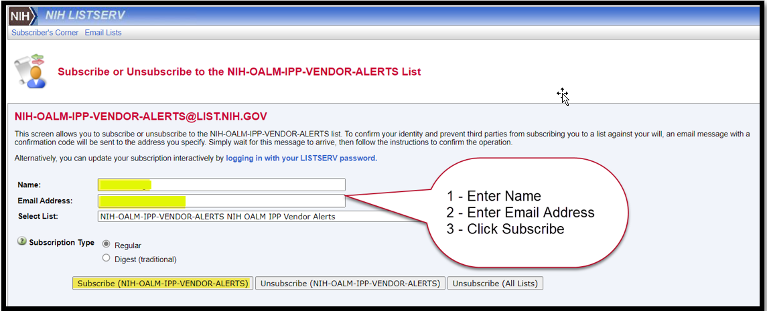

The following screen will pop-up:

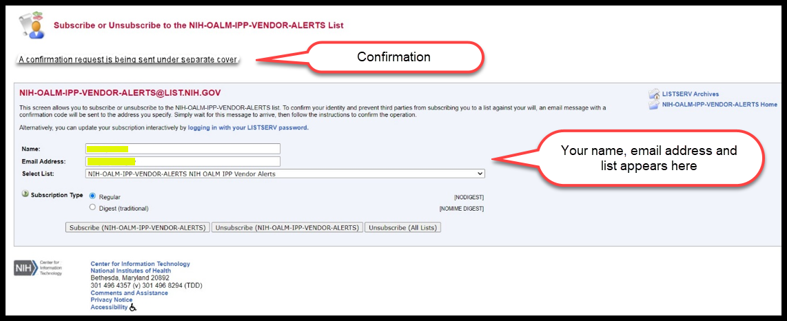

Step 2:
You will receive a confirmation email with a link. Click on the link stated in the email.
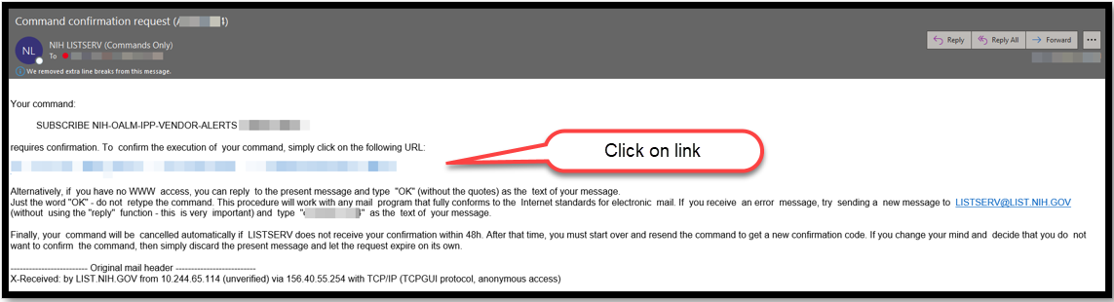

Step 3:
You will receive the following pop-up confirming subscription.
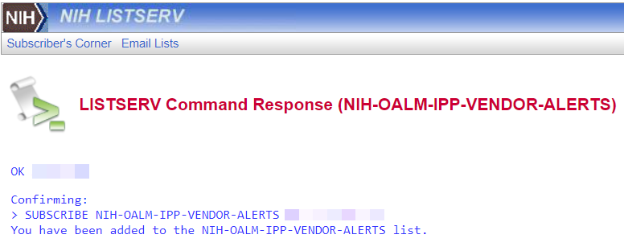
Step 4:
You will receive a confirmation email.
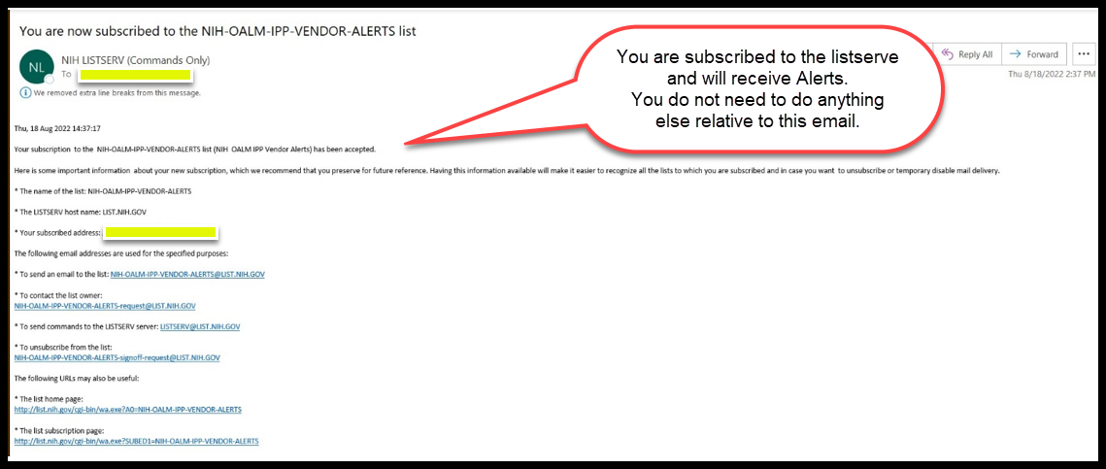
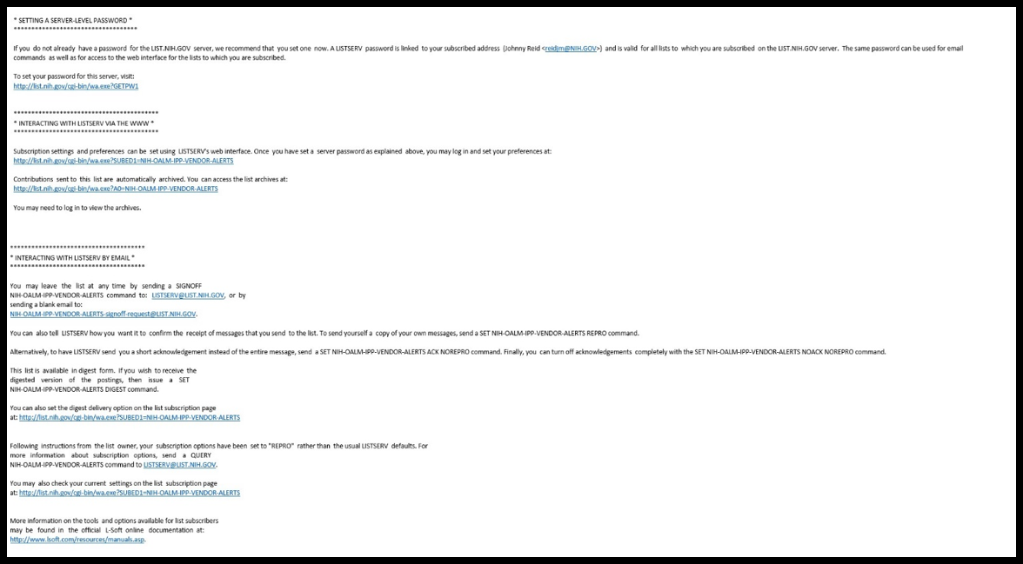

If you have any issues subscribing to the NIH-OALM-IPP-VENDOR-ALERTS, please send an email NIH-IPPinvoicing@mail.nih.gov

